Skill Week-10
- To Register Handlers, Configure Signal Actions, Handle Interrupts, Manage Signal Context, Verify Stability, Test Signal Events
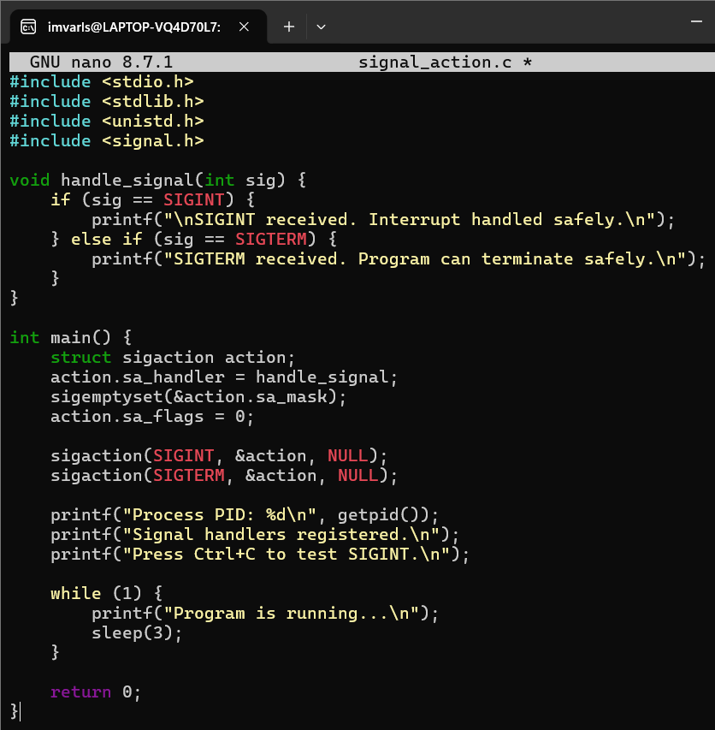

Output:

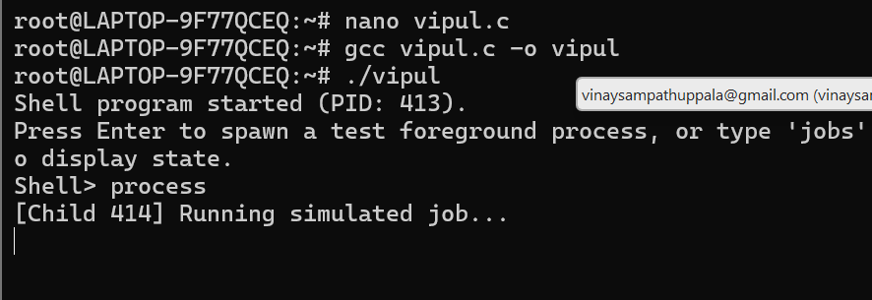
varls@
I

- 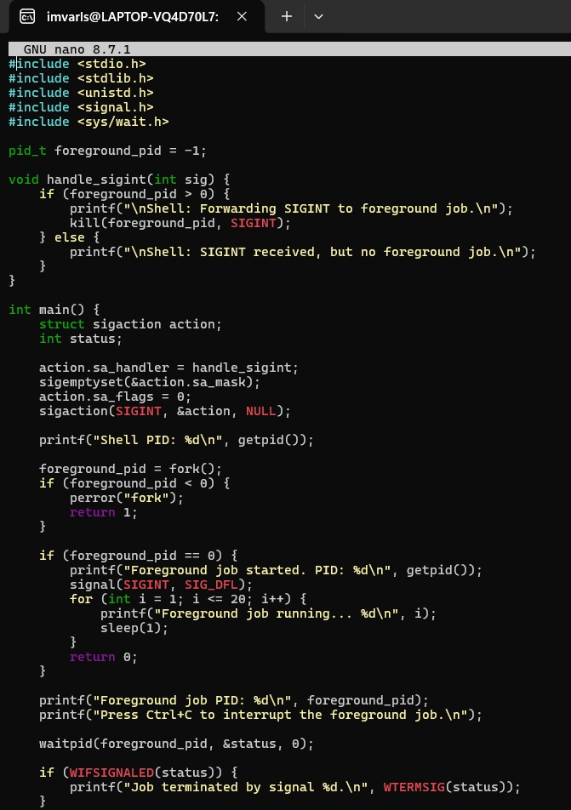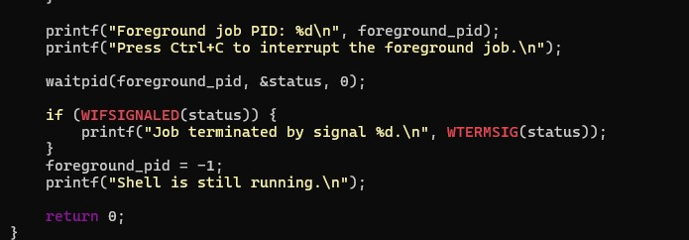To Capture SIGINT, Forward Signals, Protect Shell Process, Terminate Foreground Jobs, Update Job States, Test Interrupt Handling

Output:
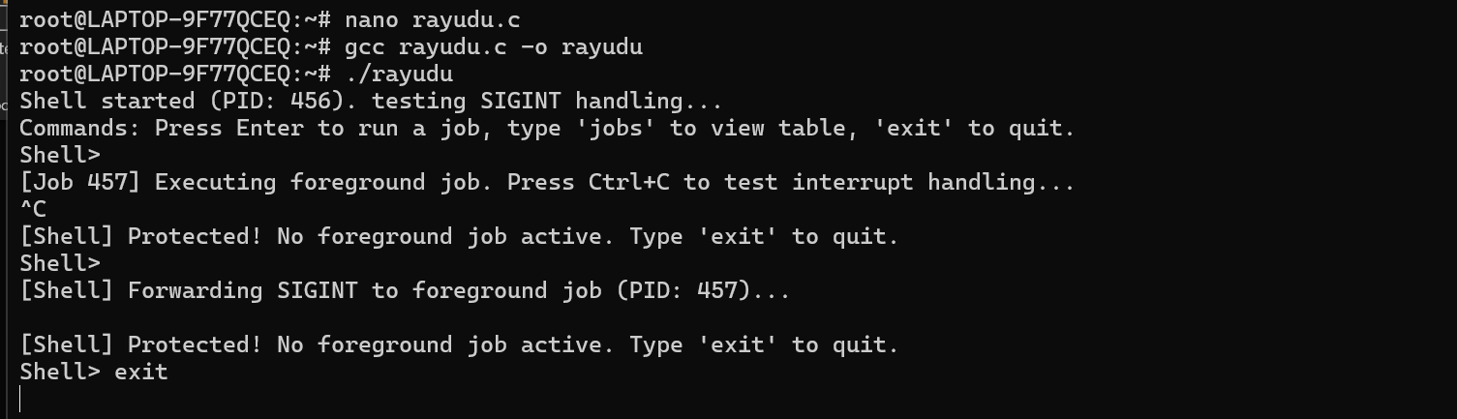

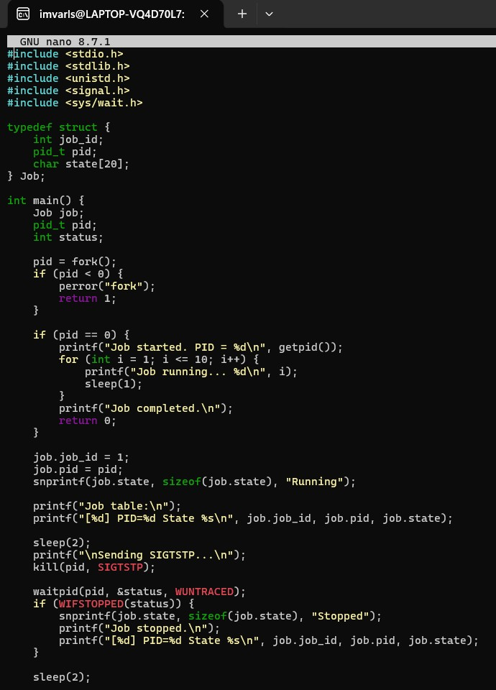
- To Capture SIGTSTP, Suspend Processes, Update Job Table, Preserve State, Resume Later, Test Suspension Workflow

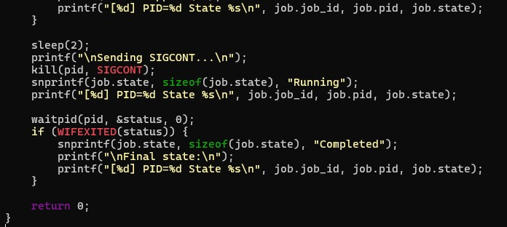

Output:
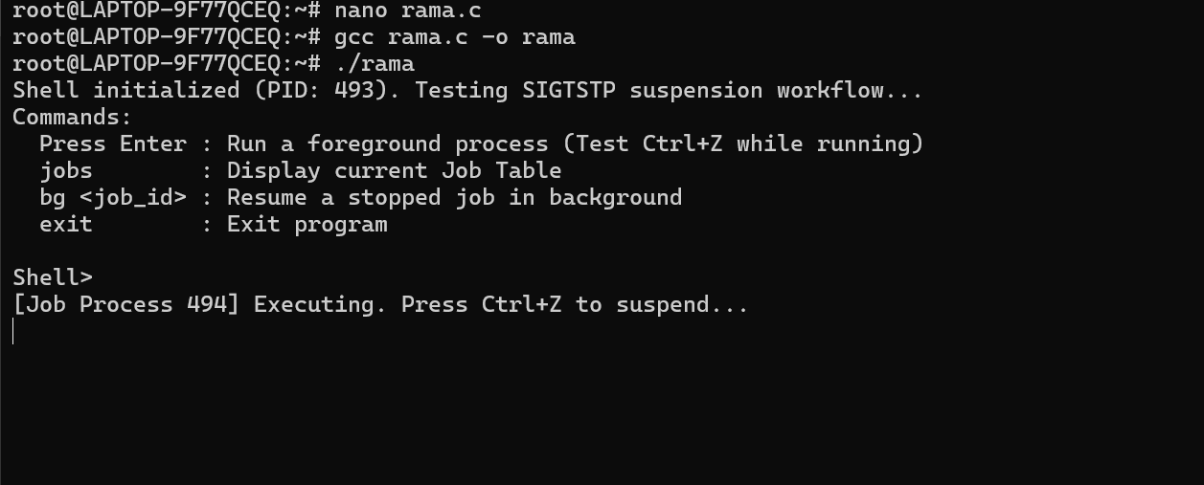

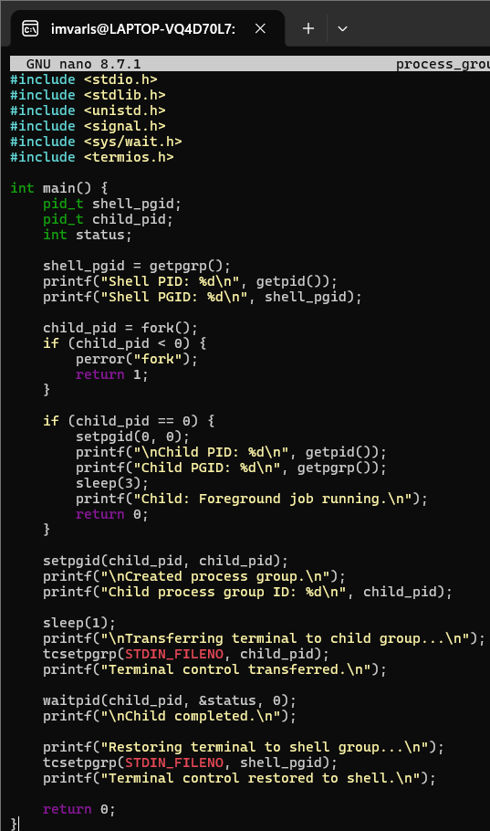
- To Create Process Groups, Assign Group IDs, Transfer Terminal Control, Restore Ownership, Coordinate Signals, Validate Behavior

Output:

